Team 508: Structural & Thermal Design of an Automotive Battery
Project Charter
Taylor Bethmann
Austin Robertson
Kaleb Sands
Skyler Heft
Mark Hibyan
FAMU-FSU College of Engineering

Team 508: Structural & Thermal Design of an Automotive Battery
Project Charter

Project Description
The objective is to design a structural and thermal management system for the Society of Automotive Engineers (SAE) Formula Hybrid Competition.

Key Goals
The primary goal for this project to design, test, and build a structurally and thermally advanced battery casing for an SAE Formula Hybrid vehicle. The battery structure will withstand the dynamic loads associated with high speed turns, impacts, and vibrations. There will be a thermal management system integrated with the battery pack to maintain the required operating temperature range. Structural and thermal analysis will be carried out using Finite Element Method. Testing methods will be chosen based on availability and accuracy to vehicle simulations.

Market
Primary Market
SAE Formula Hybrid Engineering Design Competition
Secondary Markets
Local student chapter of SAE, Electric/Hybrid vehicle manufacturers, hybrid vehicle battery engineers, Electric/Hybrid vehicle consumers

Assumptions
Battery pack advancements will be made using the previous Senior Design team’s final battery, with Nissan Leaf battery modules required by the SAE Formula Hybrid competition. Additional modules will need to be implemented into the battery pack prior to testing. Battery housing will be machined and tested for integrity in-house.

Stakeholder
Stakeholders include Dr. Michael Hays of Cummins, the FAMU-FSU College of Engineering, SAE International, and our advisors, Dr. Mohd Ali and Dr. Shayne McConomy.

Mission Statement
Produce a structurally and thermally secure battery house for an SAE Formula Hybrid vehicle.

Team Roles
Taylor Bethmann, Materials Engineer - Select materials to use in the battery, implement components and confirm validity
Austin Robertson, Project Manager - Organize meetings with advisors/sponsor and delegate/assist other duties
Kaleb Sands, Thermal Engineer - Determine appropriate cooling/heating methods based on thermal requirements
Skyler Heft, Design Engineer - Establish designs for battery housing and component placement, coordinate with thermal and structural requirements.
Mark Hibyan, Structural Engineer - Determine load and strength requirements, coordinate with designs as needed

Communication
We will meet with our Cummins sponsor, Dr. Michael Hays, via a phone call every two weeks with at least one member, and provide updates via email as progress is made. Phone calls will be confirmed at least 48 hours in advance.
Our academic advisor, Dr. Mohd Ali, will be updated monthly during his Tuesday office hours and as needed by project manager. Emails to advisors will be sent to all group members, ensuring that everyone is involved and informed.
Our team members will meet Tuesday and Thursday evenings during the scheduled class time and throughout the week as necessary. Communication outside of class will primarily be through GroupMe or text message.
At least one member is expected to respond to each message within 24 hours of receiving it. If a message is directed towards a specific member, they are expected to respond within 12 hours.

Dress Code
Casual attire is acceptable for team meetings and sponsor/advisor meetings. Business formal will be worn for presentations and professional interactions. Outfit coordination will be agreed upon 24 hours before the presentation date.

Attendance Policy
Attendance is mandatory for all in-class meetings, and expected for sponsor meetings. Members should notify group 24 hours in advance for known excused absences, unless in case of emergency. Attendance will be tracked via headcount, and noted within our group message. 3 unexcused absences from a member will result in a team meeting with Dr. Shayne McConomy to address the issue.

Statement of Understanding
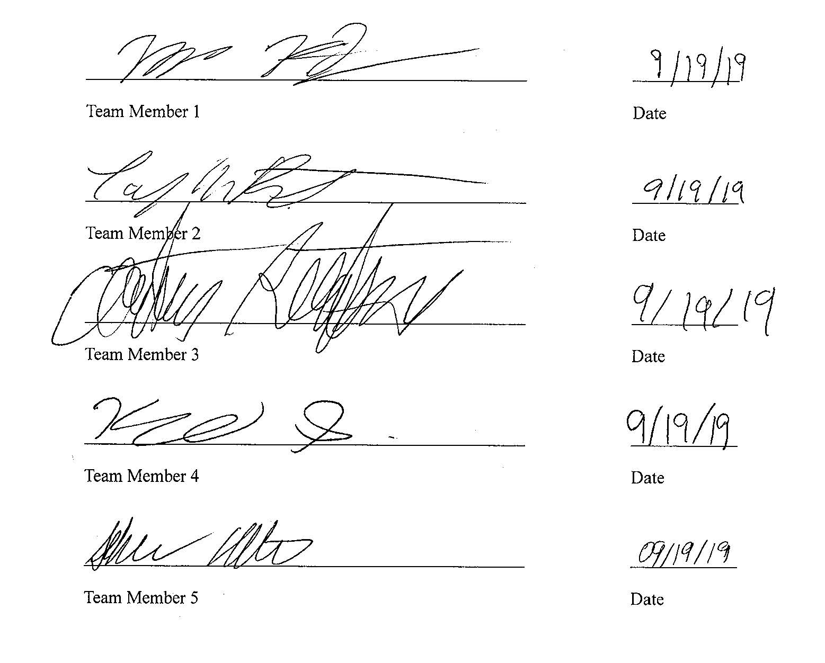
By signing this document, all members will be held responsible for adhering to the project charter. Failure to do so may result in said member being uninformed and incapable of completing project duties.

